David Cain

05/03/2019

EECE342 Project Report:

Initial Proposal

The goal of this project is to visualize audio intensity levels on a strip of WS2812b LEDs using Wi-Fi as medium of data transfer between the several microcontrollers. For this configuration, there will be a central arbiter that also acts as an access point for the LEDs to receive commands from. Majority of the audio processing will happen with the central arbiter. The goal of this is to reduce visual effects from the inherent drawback of latency from Wi-Fi. Since the central arbiter will be sending audio information to the clients, it will of course need a microphone, at the time of proposal the microphone being used was just what comes with a standard Arduino started kit.

Modifications

While reading about how to get the central arbiter acting as an access point, it turned out it was much easier to have the light do a bit of the processing on their own. Even though there is a latency due to the Wi-Fi connection, this did not cause many issues as far as displaying the sound, in other words, the lights maintained their responsiveness to the audio signals. Also, since the lights are going to take up quite a bit of space, they should operate with a couple of different modes. These are them listed

In order:

**Case 0://Soft Sleep**

This mode basically just turns the lights off, but the controllers are still fully functional and do not enter a sleep mode.

**Case 1://Sound React**

This is the showcase of the project and in this mode the central arbiter is actively sending the sound signals over the Wi-Fi UDP protocol to the two lamps connected to then display on their end.

**Case 2://All White**

This mode tells the lamps to turn all the LEDs to a white hue.

**Case 3://Fade**

In this mode, the light will be cycling through the color spectrum

**Case 4://Larson Scanner**

This is a common animation in most animation libraries and its intention is to mimic knight rider. There are a couple of LEDs that cycle back and forth cycling through the color spectrum at the same time.

**Case 5://Rainbow**

This mode has the LEDs cycle through a rainbow effect down the entire strip.

Final Implementation

For the central arbiter there is a microphone (MAX9814) to take in sound signals, a Bluetooth module (HM-10 BLE) for wireless control, and a small battery pack (two 18650s in parallel) being protected by the battery management module (TP4056). I put these into a small wooden box to make it portable enough to place near whatever sound source you’re looking to sample. Below I attached a couple photos to explain these parts a little better. As of now the mode can be controlled by a small pushbutton soldered to the board or if connected via Bluetooth, you can cycle through the modes by sending strings. A benefit to this is that the module will hold the commands until the microcontroller is ready to receive, so the input is less awkward than the button input method. There are currently 6 modes of operation.

*\*Brightness is a global variable that can be adjusted when the code is uploaded to the lamp controllers\**

I’ll describe one lamp but they’re essentially identical in components and code. The lamp has a custom perfboards that is plugged into the wall via a 36Watt 5V adapter. The lamp has a total of 119 LEDs that are individually addressable. The first one is intended to be a status LED and is soldered to the perfboard below the microcontroller, but also doubles for another purpose. The ESP8266 is a 3.3V based microcontroller which causes issues for controlling 5V logic LEDs. I found a good write up to work around this, I’ll link it below. The concept behind it has the first LED acting as a buffer LED that will be powered off of 4.3V meaning the ESP8266 will be able to control this one and when this LED sends out commands it will be at a proper voltage for the remainder LEDs to be powered off the 5V rail of the perfboard. The code of the lamps boils down to connecting to the central arbiter and then waiting for commands on what mode to be in. Once the controller receives the mode, all processing happens on the local boards, this hasn’t seemed to cause any issues for timing purposes, but I have noticed there is a slight color difference when the lamps are reacting to sound. This comes from the controllers having a local variable to control the hue that is incremented every cycle for the controller.

Future Work

Moving forward, the goal I’ve set is to try to build Phillips Hue from scratch. First, I want to setup with new hardware, this would be two different microcontrollers. An ESP-32 as the central arbiter and ESP8266 Wifi module as the lamp clients. The ESP-32 is dual core with built in wifi while the wifi module is very small with a small amount of GPIO, meaning limited world interaction. Each microcontroller would suit their purpose more. Next for an agenda would be an app interface rather than using the Arduino simple apps, this would be a standalone experience. The difficulty here is learning the go to language of android, Kotlin while also learning the structure for android programming.

**Pictures and Links:**

Write-up about the 5V to 3.3V logic conversion:

* <https://hackaday.com/2017/01/20/cheating-at-5v-ws2812-control-to-use-a-3-3v-data-line/>

Central Arbiter:

(Couple of pictures of the arbiter’s container)

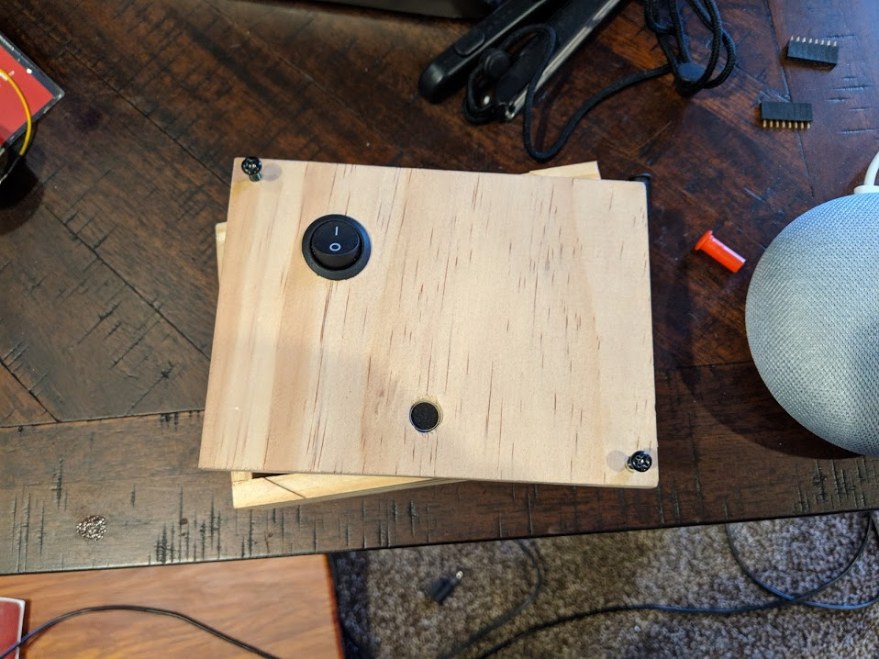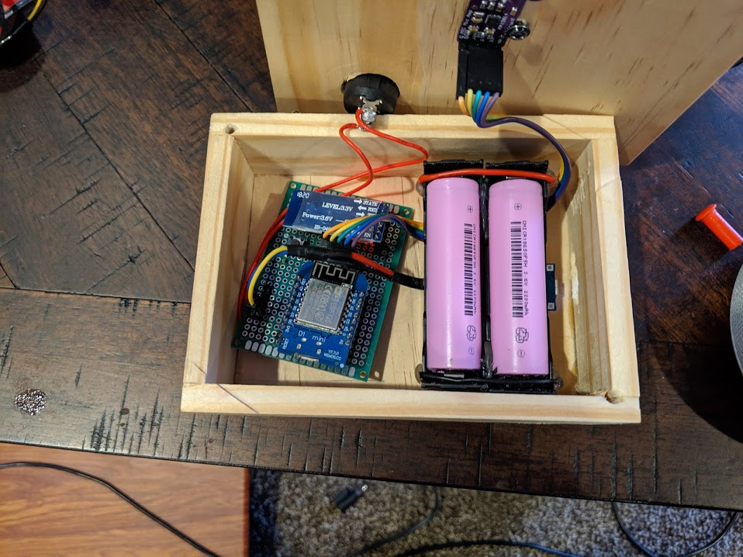

(Front and Back of perfboard)

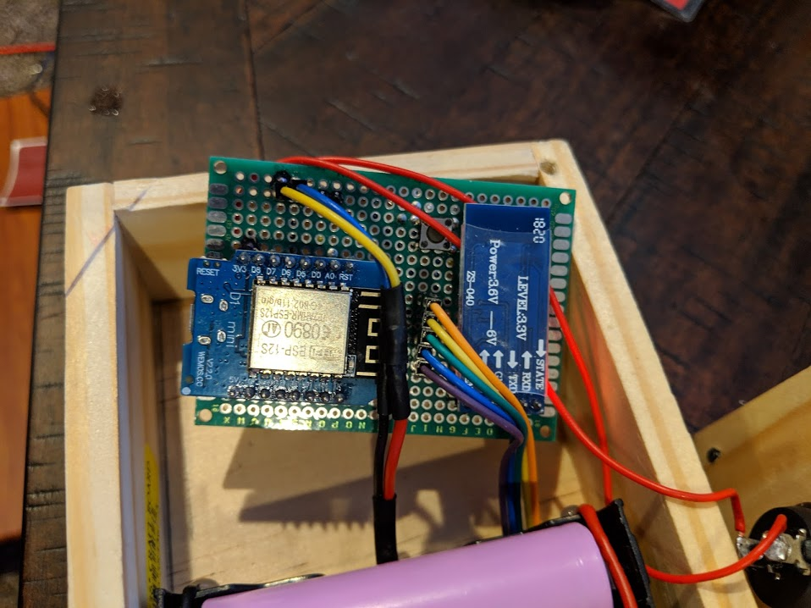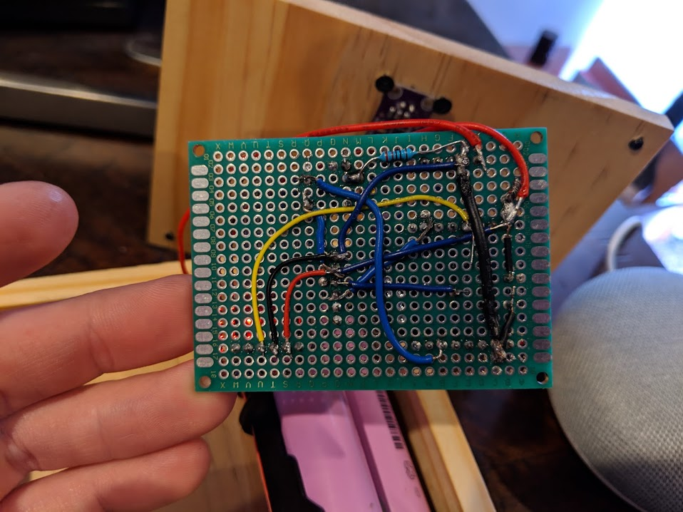

Lamps: (Front & Back of perfboard)

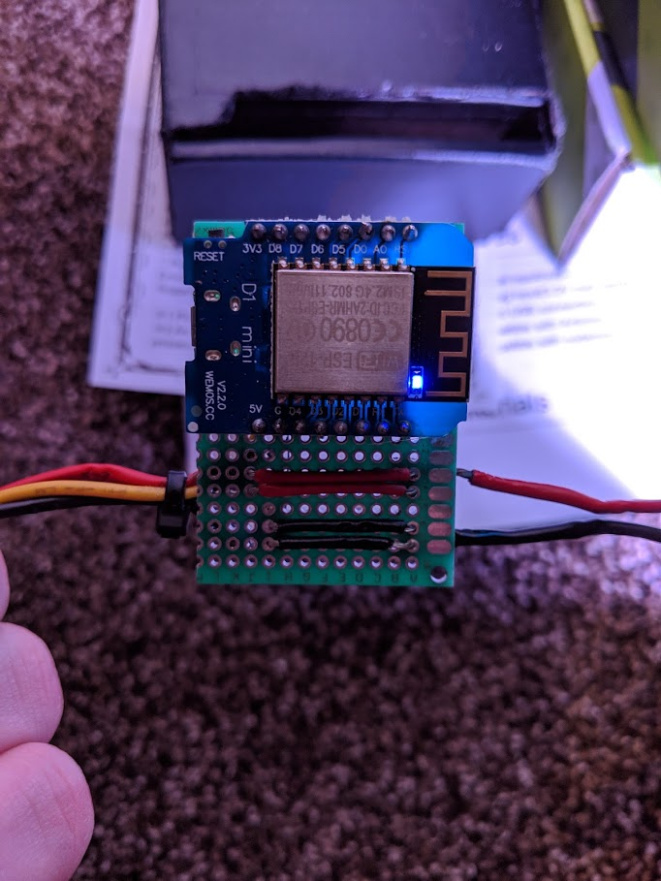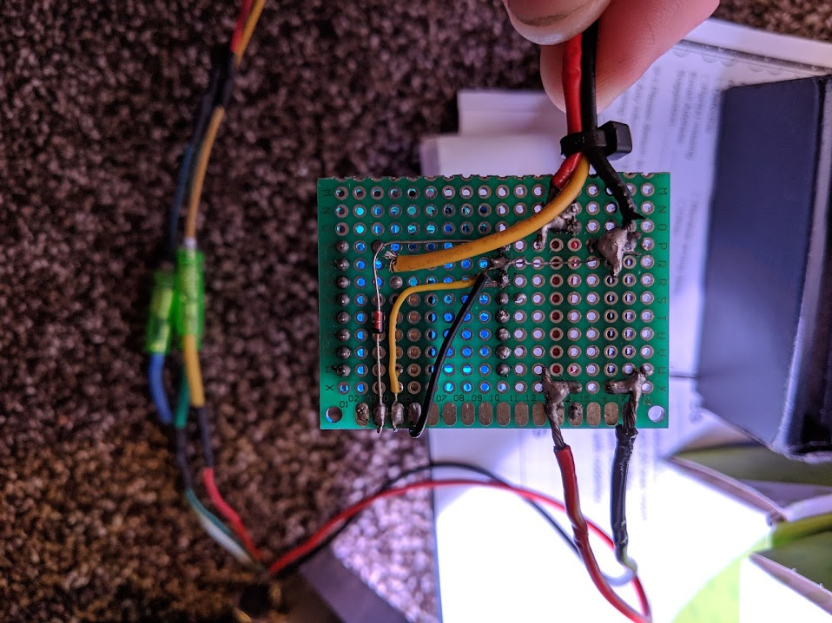

(Rainbow mode)

